**Yunus Kardaş**

**Utah Teapot Report:**

I cannot use OpenGL because glut.h file can not run in my pc and I cannot solve it. Then, I use mathematical formulas as analog.

I used mathematical formulas and did research to be able to use these formulas and equations that I wasn't sure about. Considering the project and the code given to us, I adapted some of the equations I found suitable for the project and integrated them into the code I wrote.

I used 3 different classes and these three classes are included with each other and I am using the teapot.cpp file as the main class. I only used the code given to us as a data file.

The geometry.h class contains functions for solving geometric equations.

TeaPotRayTrace.cpp is used as data file.

teapot.cpp contains the necessary functions for ray tracing and rendering and the main function.

To run the code:



Output:

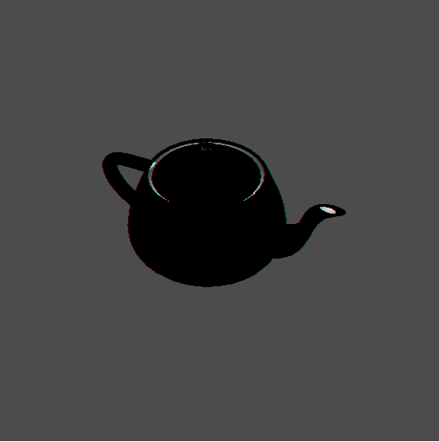

I cannot control the light, so the teapot is shaded.